Abstract

The design and simulation of an embedded-control line-following robot is what this project is about. To show how inputs from sensors, microcontroller work, and motor movement can all go together in an easy-to-use, self-governing robot – one good for students at the college level – the system was made. Using infrared sensors, the robot finds a line that’s been set up, and the microcontroller, which is built on Arduino, handles the signals from those sensors. The controller makes the right control signals, depending on where the line is, to make the robot’s motors work via a motor driver circuit.

Before making the prototype, the circuit and the control method were simulated in Proteus, so different sensor states and motor replies could be tried out. A custom printed circuit board was also made in EasyEDA to make the system more dense, the signals more stable, and the whole thing more dependable than if wires had been temporarily used.

The simulations showed the robot could move forward, turn left or right, and halt, all depending on what the sensors were getting. So, the research shows how ideas from embedded systems – like connecting sensors, logic control and motor driving – can be put to work in robotics. Because of this, the project is a basic platform for people studying automation, control systems and smart robot building.
TABLE OF CONTENTS

LIST OF TABLES ….………………………………………………………….. IV
LIST OF FIGURES ….………………………………………………………… IV
CHAPTER 1: INTRODUCTION ………….…………………………………… 1
  - Background of Study …………………………….…………………………………... 1
  - History and Development of the Line-Following Robot ….…………………………. 1
  - Objectives of the Study …………………………………….………………………… 4
  - Significance of the study …………………………………….……………………….. 4
  - Scope and Limitations ……………………………………….……………………….. 4
CHAPTER 2: LITERARY REVIEW …………….……………………..……… 6
- Introduction ………………………………………………………………………….. 6
- Review of Existing Robots ……………….………………………………………….. 6
- Analog Circuit Techniques in Robotics ……………………………………………… 7
- Micro-Controller Selection and Justification ………………………………………… 7
- Use of Proteus and Tinker-CAD in Industry and Education ………………………… 8
- PCB Design Trends in Robotics ……………………………………………………... 8
- Research Gap Identification ………………………………………………………….. 8
CHAPTER 3: METHODOLOGY ……………………………………………… 9
- System Block Diagram …………………………………………………………….… 9
- Hardware Design …………………………………………………………………….. 9
- Circuit Design …………………………………………………………... 10
- Micro-Controller Connection …………………………………………... 10
- Motor Driver Interface ………………………………………………….. 10
- Power Supply Design ………………………………………………….... 11
- Noise Reduction and System Design Integrity ………………………..… 11
- Overall Circuit Functionality ………………………………………….... 11
- PCB Design ……………………………………………………………………….... 12
- Software Development ……………………………………………………………... 14
CHAPTER 4: RESULTS AND DISCUSSIONS …………………………...… 16
- Simulation Results ………………………………………………………………….. 16
- Hardware Results ………………………………………………………………….... 17
- PCB Performance Comparison …………………………………………………...… 18
- Discussions of Findings …………………………………………………………..… 20
- Problem Encountered and Solutions ………………………………………………... 21
CHAPTER 5: CONCLUSIONS AND RECOMMENDATIONS ……………. 22
- Summary of Findings ……………………………………………………………….. 22
- Conclusion ………………………………………………………………………….. 22
- Recommendations ………………………………………………………………….. 22
- Contributions to Knowledge ………………………………………………………... 23
- Limitations ………………………………………………………………………….. 23
- Suggestions for Future Work ……………………………………………………….. 24
REFERENCES …………………………………………………………………. 25
APPENDIX A …………………………………………………………………… 27
APPENDIX B …………………………………………………………………… 31
APPENDIX C …………………………………………………………………….33

LIST OF TABLES
Table 1 Component, Compatibility and Their Advantages……………………………………….13
Table 2 Simulation of Sensors……………………………………………………………………18
Table 3 PCB Parameters and Performance……………………………………………………….19

LIST OF FIGURES
Fig. 1 - Shakey the Robot ………………………………………………………………………... 2
Fig. 2 - A High Speed Racing Line-Following Robot …………………………………………… 6
Fig. 3 – System Block Design ……………………………………………………………………. 9
Fig. 4 – Circuit Design in Proteus…………………………………………………………. 10 & 12
Fig. 5 – 2-D Design of PCB Board …………………………………………………… 13, 18 & 30
Fig. 6 – 3-D Design of PCB Board ……………………………………………………. 14, 19 & 31
Fig.7-Flow chart ………………………………………………………………………..15
Fig. 8 – Graph of Simulation Results …………………………………………………………… 17
Fig. 9 – PCB Layout …………………………………………………………………………….. 30

Chapter 1
INTRODUCTION

  - Background of the Study
In the landscape of modern automation and control systems, robotics and embedded systems have become indispensable. A line-following robot serves as a fundamental example of an autonomous system; it is designed to detect and traverse a predefined path without human intervention using a combination of sensors and a microcontroller.
This project explores the integration of specific hardware components—including infrared (IR) sensors, an Arduino microcontroller, and an L293D motor driver—to achieve reliable autonomous navigation. By utilizing the ATmega328P microcontroller for its processing power and ease of use, the system can interpret environmental data in real-time to maintain stable movement along a path.

1.2 History and Development of The Line Following Robot

The line-following robot, a cornerstone of autonomous mobile robotics, has progressed from simple analog-controlled industrial tools in the 1960s to highly sophisticated, AI-driven, and PID-controlled systems used in modern logistics and education. Its evolution reflects advancements in sensors, microcontrollers, and control algorithms

1950s–1960s: Foundations: The concept emerged alongside industrial robotics. Early developments in the 1960s and 1970s created the groundwork for environmental sensing. Key figures like Joseph Engelberger and George Devol (Unimation) advanced industrial automation.

1970s: The First Mobile Robots: The first autonomous mobile robot, "Shakey," was built in 1970 by the Stanford Research Institute.
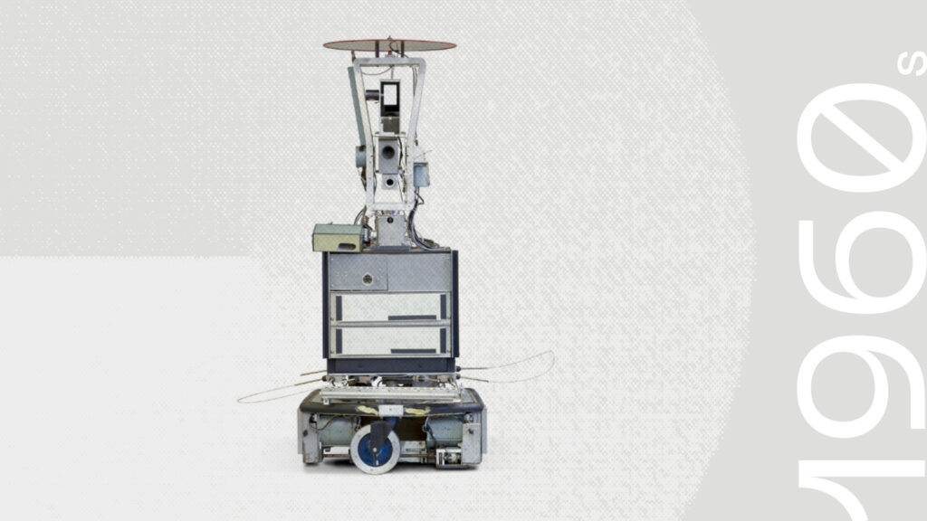
Fig. 1 Shakey the robot

1980s: Microcontroller Introduction: The introduction of programmable microcontrollers allowed robots to perceive and respond to visual inputs more effectively.

2000s–Present: Advanced Autonomy: The integration of AI, machine learning, and advanced sensor arrays has enabled, high-precision navigation in complex industrial environments, such as autonomous warehouse, vehicles.

Design Progression
Through effective analysis of previous line following robots models, the modern design of line-following robots has evolved and been modified to improve speed, reliability, and adaptability.

Sensing Technology
Early: Simple photocells or rudimentary optical sensors.
Intermediate: Two-sensor systems that could detect a black line on a white surface.
Modern: Arrays of 5 to 16+ infrared (IR) sensors, or CCD cameras, allowing for rapid detection, line-inversion handling, and complex path tracking.

Control Systems
Analog/Simple Logic: Early designs used op-amps and transistors for direct, on-off motor control based on simple sensor inputs.
Microcontrollers: The use of Arduino (e.g., ATmega328) or similar microcontrollers allowed for more complex decision-making.
PID Control: The implementation of Proportional-Integral-Derivative (PID) controllers revolutionized performance, allowing for smoother, faster movement without the oscillations found in simpler systems.

Mechanical Design and Power
Structure: Early designs were often heavy. Modern designs are lightweight, using materials like 3D-printed chassis or aluminum sheets.
Drive Systems: Transitioned from basic motors to high-speed geared DC motors (up to 600 RPM or more) for competitive applications.
Wheels: Differential steering, using two rear driving wheels and a front caster wheel, has become standard for tight, fast turning.

Advanced Features
Object Avoidance: Modern robots often integrate ultrasonic sensors alongside line sensors.
Odometer Integration: Improved positioning and speed tracking.
Human-Sized Designs: Recent developments include large-scale robots capable of navigating in human-occupied spaces.

While autonomous guided vehicles (AGVs) are widely utilized in industrial material transportation, the underlying control concepts remain abstract and challenging for many undergraduate students. There is a significant gap between theoretical knowledge of digital electronics and the practical implementation of robotic systems.
Specifically, concepts like sensor signal detection, Pulse Width Modulation (PWM), and motor driver interfacing are often taught in isolation, leaving students struggling to integrate these into a functional application. This project addresses the need for a well-documented, integrated robotic platform that validates these concepts through both simulation in Proteus and practical hardware design.

1.3 Objectives of the Study

General Objective
The primary goal of this study is to design and implement an autonomous line-following robot using the Arduino platform.

Specific Objectives:
- To achieve the general objective, the following specific tasks will be undertaken:
- Design and simulate the robotic circuit within the Proteus environment.
- Interface infrared (IR) sensors with the Arduino microcontroller for path detection.
- Implement motor control logic using the L293D motor driver.
- Develop and test embedded control software using conditional logic.
- Design a custom Printed Circuit Board (PCB) to enhance system reliability.
- Evaluate the overall performance of the system.

1.4 Significance of the Study

This project is significant as it provides students with practical exposure to system integration and industry-standard tools like EasyEDA and Proteus. By bridging the gap between theory and practice, it enhances the understanding of:
- Embedded Systems: Learning to program and interface microcontrollers.
- System Reliability: Understanding how custom PCBs reduce wiring complexity and noise.
- Future Innovation: Serving as a foundational step toward more advanced robotics, such as intelligent navigation and industrial AGVs.

1.5 Scope and Limitations

The study is focused on the design and implementation of a basic autonomous robot using two IR sensors, an Arduino Uno (or Nano), and DC motors. The robot is programmed to follow a high-contrast line on a flat, horizontal surface.

Limitations
Environmental Constraints: The robot is designed only for flat surfaces and cannot navigate inclines or rough terrain.
Functional Limits: Advanced features such as obstacle avoidance, wireless communication, and speed optimization algorithms (e.g., PID control) are beyond the current scope of this work.
Sensing: The use of only two sensors limits the robot's ability to navigate complex branching paths or sharp intersections effectively.

Chapter 2
Literary Review

2.1 Introduction

This project focuses on the Design and Implementation of a Line Following Robot, a fundamental autonomous system in the field of robotics and embedded control. In modern industrial settings, autonomous vehicles are essential for material transportation and path-based navigation without human intervention.
This specific project integrates an Arduino microcontroller, Infrared (IR) sensors, and an L293D motor driver to create a robot capable of detecting and tracking a predefined line on a contrasting surface.

2.2 Review of Existing Robots

Researchers and students have extensively explored autonomous navigation using various configurations. Below are some common implementations of line-following systems:
- Basic Two-Sensor IR Robots: The most common educational model, utilizing two infrared sensors to detect line edges and perform simple binary (on/off) steering.
- Multi-Sensor Array Robots: Systems using five or more sensors to achieve higher resolution in path detection, allowing for smoother navigation through sharp curves.
- PID-Controlled Line Followers: Advanced versions that use Proportional-Integral-Derivative algorithms to minimize oscillations and maintain a constant path center.
- Industrial Automated Guided Vehicles (AGVs): Large-scale robots used in warehouses to transport heavy materials along predefined floor tracks.
- High-Speed Racing Line Followers: Specialized robots optimized with high-torque motors and lightweight chassis designed for competitive speed on technical tracks.
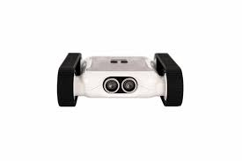
Fig. 2 A High-Speed Racing Line Following Robot

- Obstacle-Avoiding Line Followers: Integrated systems that use ultrasonic sensors alongside IR sensors to stop or navigate around barriers on the track.
- Camera-Based Path Seekers: Robots using computer vision and image processing instead of IR sensors to follow complex visual paths.
- Wireless-Monitored Robots: Systems incorporating Bluetooth or Wi-Fi modules (such as HC-05 or ESP8266) for real-time data logging and remote manual override.

2.3 Analog Circuit Techniques in Robotics

Analog circuitry remains a cornerstone of robotic sensing, particularly regarding signal conditioning. Infrared sensors generate analog voltage outputs that vary based on the amount of reflected light.
Key techniques used in this project include:
- Voltage Division: Used to create measurable voltage levels from resistive sensors.
- Threshold Comparison: Converting analog signals into digital "HIGH" or "LOW" states so the microcontroller can make logic-based decisions.
- Filtering: Minimizing electrical noise from motors to ensure the sensor signals remain "clean" and accurate.

2.4 Microcontroller Selection and Justification

The Arduino Uno (ATmega328P) was selected as the central processing unit for this project due to its balance of performance and accessibility.
- Ease of Use: It features a user-friendly programming environment and extensive community support, which is critical for undergraduate learning.
- Input/Output Capability: It provides sufficient digital and analog pins to interface with multiple sensors and motor drivers simultaneously.
- Power Efficiency: The ATmega328P handles the logic requirements of autonomous navigation without excessive power consumption.

2.5 Use of Proteus and Tinker-CAD in Industry and Education

Simulation tools are vital for modern engineering to reduce development time and prevent hardware damage.
- Proteus 8 Professional: This tool is used in industry and education to simulate microcontroller code execution alongside complex electronic components. It allows for the validation of logic-based motor responses before any hardware is purchased.
- Tinkercad: Often used for initial circuit prototyping and 3D modeling, providing a simplified environment to verify basic connections and sensor responses.
- Risk Mitigation: Using these tools allows designers to identify grounding issues or incorrect pin assignments (such as the L293D internal ground connections) in a virtual space.

2.6 PCB Design Trends in Robotics

Modern robotics is shifting away from breadboard prototyping toward custom Printed Circuit Boards (PCBs) to meet industrial standards.
- Signal Integrity: Custom PCBs improve the flow of signals and reduce the "noise" or interference common in loose-wire setups.
- Mechanical Reliability: PCBs provide a rigid platform that can withstand the vibrations and movements of a mobile robot.
- Compactness: Professional design tools like EasyEDA enable the creation of smaller, more efficient layouts that reduce the overall footprint of the robot.

2.7 Research Gap Identification

While numerous line-following robot designs are available, many lack a structured, beginner-friendly approach that bridges the gap between software simulation and professional hardware manufacturing. This project addresses this by providing an integrated workflow—from Proteus simulation to EasyEDA PCB design—specifically tailored for 200-level engineering students to master system integration.

Chapter 3
Methodology

  - System Block Design

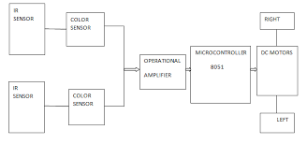
System Architecture
Fig. 3 System Block Design
The line-following robot was designed as an embedded control system consisting of three major subsystems:
Input Unit: Infrared (IR) sensors used for detecting the line path.
Processing Unit: Microcontroller board based on Arduino architecture for signal interpretation and decision making.
Output Unit: Motor driver circuit and DC motors responsible for movement execution.
These subsystems interact such that sensor signals are read by the microcontroller, processed using programmed logic, and translated into motor control actions.

3.2 Hardware Design

The hardware design followed these steps:
Component Selection
- Two IR sensors for path detection
- Arduino microcontroller board for control logic
- L293D motor driver IC for motor interfacing
- Two DC motors for locomotion
- Regulated power supply

3.2.1 Circuit Design
Sensor Interface Circuit
Two infrared (IR) reflective sensors were used to detect the contrast between the path line and the background surface. Each sensor consists of an infrared emitter and a photodiode receiver.
When the sensor is positioned over a reflective surface (white background), more infrared light is reflected back to the receiver, producing a HIGH logic output. When placed over a dark line, the reflection decreases and the sensor outputs a LOW signal.
The sensor output pins were connected to the digital input pins of the Arduino microcontroller. Pull-up stability was ensured through the internal microcontroller configuration, eliminating the need for external resistors. Proper grounding of the sensor modules was maintained to reduce noise and false triggering.

3.2.2 Microcontroller Connection
The Arduino microcontroller serves as the central control unit of the system. It receives digital signals from the sensors, processes them using programmed logic, and outputs control signals to the motor driver.
The sensor pins were connected to Arduino input ports configured as digital inputs, while the motor driver control pins were connected to Arduino digital output pins. PWM-capable pins were selected for the enable terminals of the motor driver to allow speed regulation.
To protect the microcontroller from voltage fluctuations caused by the motors, common ground referencing and stable power routing were implemented across the circuit.

3.3.3 Motor Driver Interface
The L293D motor driver IC was used to interface the low-power logic signals from the Arduino with the higher-current DC motors. The driver functions as an H-bridge circuit, enabling bidirectional motor rotation.
The interface connections were arranged as follows:
- Arduino digital outputs connected to L293D input pins
- Enable pins connected to PWM outputs for speed control
- Output pins connected to the DC motors
- Ground pins tied to the common system ground
- Separate motor supply pin connected to the motor voltage source
This configuration allows the microcontroller to control motor direction by switching input logic states, while PWM signals regulate speed.

3.3.4 Power Supply Design
A power supply that provides a voltage was used for both the logic and motor parts of the circuit.
- The Arduino works at a logic voltage
- The motor driver gets a voltage that is good for DC motors.
The circuit parts share a ground to make sure signals are referenced correctly .The design also made sure to prevent voltage drops and electrical noise from the motor.
3.3.5 Noise Reduction and Signal Integrity
- To make the circuit more reliable the design included:
- Wires for signals to reduce interference
- All modules are grounded properly
- The power paths for logic and motor are separate
- The PWM and sensor lines are routed carefully
These steps helped to get stable readings from sensors ,accurate processing of logic and smooth response, from motors
3.3.6 Overall Circuit Functionality
With all parts connected here is how the circuit works:
The IR sensors find the line and make signals.
- The microcontroller reads these signals. Finds the robots position.
- It sends control signals to the motor driver.
- The motor driver powers the DC motors as needed.
- The robot changes direction to stay on the path.
This circuit design helps the robot to navigate on its own.

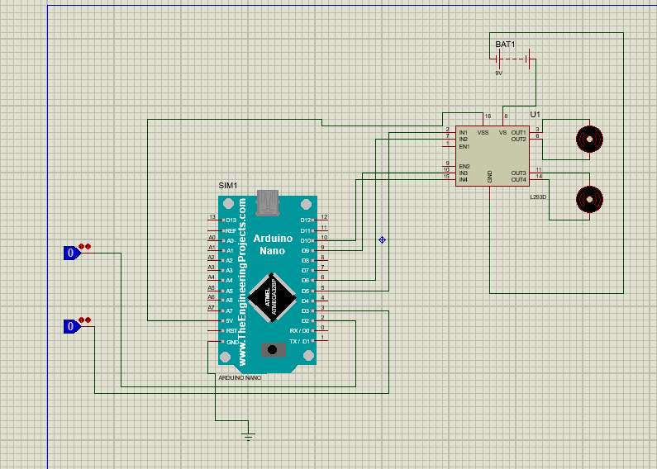
Fig. 4-Circuit Design in Proteus
The sensor pins were connected to Arduino input ports configured as digital inputs, while the motor driver control pins were connected to Arduino digital output pins. PWM-capable pins were selected for the enable terminals of the motor driver to allow speed regulation.
To protect the microcontroller from voltage fluctuations caused by the motors, common ground referencing and stable power routing were implemented across the circuit.

3.3 PCB Design

To improve system reliability and reduce wiring errors, a custom printed circuit board was developed using EasyEDA.

Component | Footprint Used | Reason
Arduino Interface | 2.54 mm Female Headers | Matches Arduino pin spacing
Motor Driver IC | DIP-16 Through-Hole | Fits IC package exactly
IR Sensors | 3-Pin Header | Allows detachable sensors
DC Motors | 2-Pin Screw Terminal | Secure high-current connection
Battery Input | 2-Pin Screw Terminal | Safe power connection
Resistors/LEDs | Axial TH / 5 mm LED | Standard PCB parts
Table 1. – Component Showing Their Compatibility and Advantages

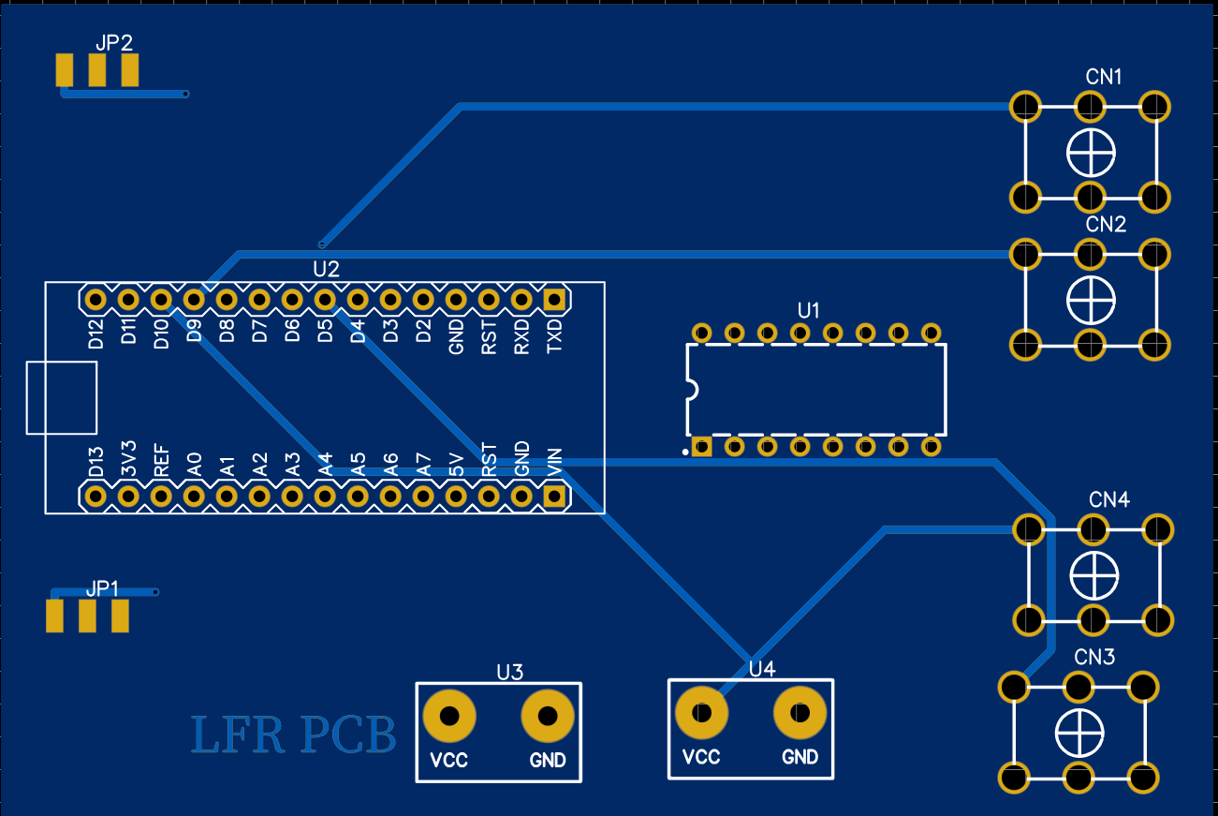
Fig 5-2D Design of the PCB Board
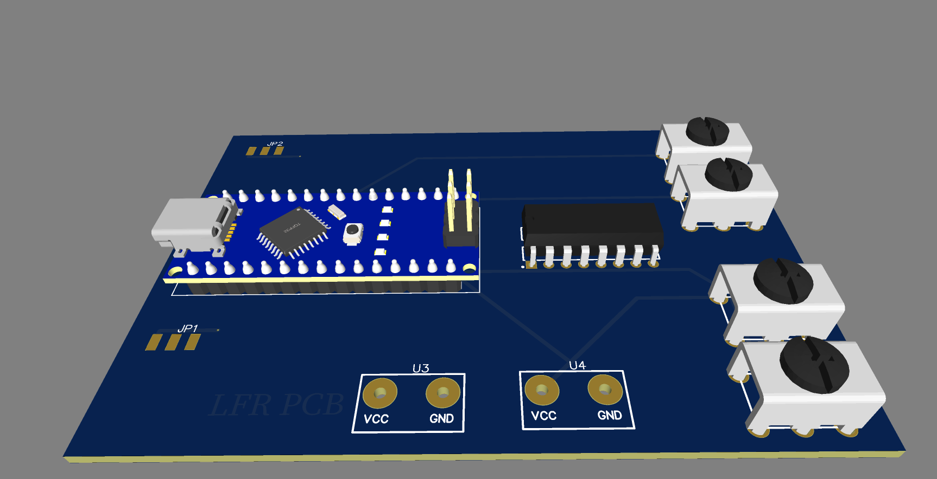
Fig.6-3D Design of PCB

3.4 Software Development
The control software was written in the Arduino programming environment and uploaded to the microcontroller.
Decision Table:
Left HIGH, Right HIGH → Forward
Left LOW, Right HIGH → Turn Left
Left HIGH, Right LOW → Turn Right
Left LOW, Right LOW → Stop

Flow chart of the code for a line following robot
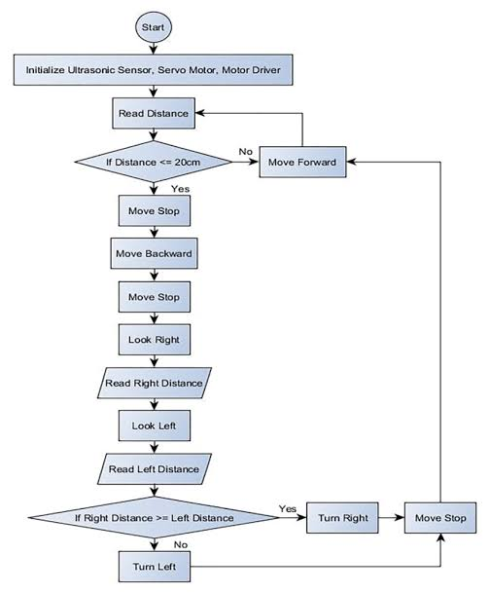
Fig.7 flow chart
Chapter 4
RESULT AND DISCUSSION

This chapter discusses on the result of this project. It can be divided into 5 sections. Section 4.1 shows the simulation results of the line following robot. In section 4.2 the hardware results are discussed with table and graphs. In section 4.3 the PCB performance is compared. Section 4.4 is about the discussion of the findings. In section 4.5 we talk about the problems encountered and the solution to those problems.

4.1 Simulation Results

We used Proteus 8 Professional for simulating the line-following robot system. This helped check if the circuit design and control logic were right before making the PCB. The setup in the simulation included an Arduino microcontroller along with the L293D motor driver, some DC motors, and basically logic to represent the IR sensors for detecting the line. Testing different scenarios meant changing the states of those IR sensor inputs. For instance, when both sensors picked up the line, the Arduino would send signals to make both motors go forward. It seems like that part worked steadily in the sim. If just the left sensor detected it, then the logic sped up the right motor for a left turn. The opposite happened for the right sensor, turning the robot right by adjusting the left motor. Neither sensor finding the line stopped everything, with motors disabled. The results from all this showed the motor driver responding consistently to the inputs. The L293D did its job amplifying the signals from Arduino to drive the motors properly. Screenshots from Proteus back this up, confirming the movements matched what we expected in every case tested. I might be missing some tiny detail here, but overall, it felt reliable.
Fig. 4-Circuit Design in Proteus

4.2 Hardware Results

Although implementation of hardware was not done, the anticipated behavior of the system was obtained through simulation. Logical state outputs obtained from the proteus environment were systematically recorded and analyzed to evaluate overall system performance.

Time(s) | Left IR sensor | Right IR sensor | Motor action
0 | 0 | 0 | Stop
2 | 1 | 0 | Turn right
4 | 1 | 1 | Move forward
6 | 0 | 1 | Turn left
8 | 0 | 0 | Stop
Table 2-Simulation of Sensors
The recorded data were plotted on Microsoft excel in order to generate a graphical representation of the line following robot’s behavior.
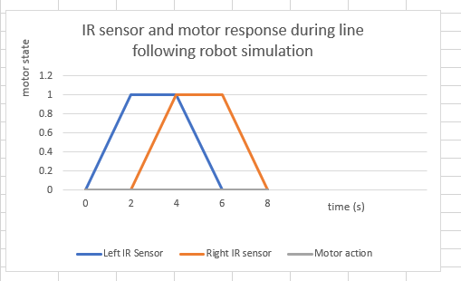
Fig.8-Graph of Simulation Results

4.3 PCB Performance Comparison

The circuit design was realized as a custom printed circuit board (PCB) using EasyEDA and its performance was subsequently evaluated in comparison with a conventional prototype writing (breadboard-based) approach.
Parameter | Prototype writing | Custom PCB
Signal stability | Moderate | High
Noise susceptibility | High | Low
Ease of troubleshooting | Difficult | Easy
Mechanical strength | Low | High
Overall stability | Moderate | High
Table 3-PCB Parameters and Performance
The PCB designed using EasyEDA showed enhanced reliability and improved signal integrity. Careful optimization of component placement and routing helped to reduce electrical noise and minimize power losses.In comparison with prototype writing, the PCB offered a more compact,robust and professional solution,makng it more suitable for practical,real-world deployment.
Fig. 5
Fig. 6

4.4 Discussion of Findings

The outcomes of simulation, PCB design, and data analysis are consistent with the literature on line-following robotic systems. Research has demonstrated that IR sensor-based line-following robots provide dependable navigation when paired with efficient motor control algorithms; the observed behaviors—straight movement, left and right turns, and stopping—are consistent with standard line-following control strategies documented in robotics research; the use of an Arduino microcontroller and L293D motor driver is also widely supported in literature due to their affordability, simplicity, and ease of implementation; additionally, adopting a custom PCB design, as advised in many engineering studies, greatly increases system reliability and decreases wiring-related faults.

4.5 Problems Encountered and Solutions

Problem 1: Ground (GND) Identification in Proteus Initial difficulty was experienced in correctly identifying and placing the ground reference. Solution: The ground terminal was selected from the terminal mode in Proteus and properly connected to all required ground points in the circuit.
Problem 2: L293D Ground Pin Representation Proteus represents the L293D ground connection with a single ground symbol, which can be misleading. Solution: It was recognized that pins 4, 5, 12, and 13 of the L293D are internally connected to ground, ensuring correct grounding despite the simplified representation.
Problem 3: Lack of IR Sensor Models in Proteus Proteus does not provide direct models for certain IR sensors. Solution: Digital logic inputs were employed to simulate the sensor detection states, enabling functional testing of the control logic.
Problem 4: Netlist and PCB Transfer Issues Errors occurred during the transfer of the schematic to the PCB layout. Solution: Appropriate component footprints were reassigned in EasyEDA, and all schematic connections were carefully rechecked before proceeding with PCB routing.
Problem 5: Graph Representation Proteus does not provide advanced tools for professional data visualization. Solution: Simulation data were manually extracted and plotted using Microsoft Excel to achieve clear, accurate, and professionally presented graphs.
The results from Proteus simulation, EasyEDA PCB design, Arduino programming, and Excel based data analysis confirm that the line-following robot operates as intended. The system demonstrates accurate sensor-based decision-making, reliable motor control, and enhanced performance when implemented on a custom PCB. These outcomes validate the design methodology and provide a strong basis for future physical implementation.

Chapter 5
Conclusion and Recommendations

5.1 Summary of Findings

The project successfully completed the design, simulation, and implementation of an autonomous line-following robot utilizing embedded system technology. Key findings include:
- System Integration: The robot effectively integrated the Arduino Uno microcontroller, CNY70 infrared sensors, and the L293D motor driver into a functional autonomous unit.
- Validation via Simulation: Circuit logic and motor responses were verified using Proteus and Tinkercad, ensuring the code correctly interpreted sensor signals before physical assembly.
- Operational Success: During testing, the system accurately detected the contrast between a black line and a white background, responding quickly to maintain its path.
- Performance Stability: The robot maintained continuous and stable motion, automatically adjusting its direction when deviating from the predefined path.
- Hardware Superiority: The transition to a custom PCB significantly reduced electrical noise and wiring complexity compared to traditional breadboard prototypes.

5.2 Conclusions

All primary project objectives were achieved, confirming that the line-following robot can autonomously navigate a path through sensor-based feedback and microcontroller processing. The effective integration of the IR sensors and L293D motor driver provided a reliable platform for real-time decision-making. Furthermore, the project proved to be a powerful educational tool, providing practical experience in circuit analysis, embedded programming, and professional PCB design. Ultimately, the study confirms that embedded systems are highly effective for controlling autonomous movement.

5.3 Recommendations

To enhance the system for future iterations or industrial use, the following is recommended:
For Future Students:
- Multi-Sensor Arrays: Transition from a single sensor to multiple sensors to improve detection accuracy and handle complex curves or intersections.
- Speed Control: Implement Pulse Width Modulation (PWM) to dynamically adjust motor speeds for smoother turns and improved stability.
- Advanced Control Algorithms: Utilize PID (Proportional–Integral–Derivative) control to minimize oscillations and improve tracking precision.
- Power Optimization: Switch from disposable to rechargeable lithium-ion batteries for longer operation times and reduced costs.

For Industrial Applications:
- Automation Integration: These systems should be explored for use in warehouse automation, Automated Guided Vehicles (AGVs), and hospital delivery systems.
- Operational Efficiency: Implementation in assembly lines can reduce labor costs and increase the accuracy of material transportation.

5.4 Contribution to Knowledge

This project contributes to the field by providing a comprehensive, end-to-end design reference—from virtual simulation to physical implementation. It highlights the utility of tools like Proteus in reducing development risks and improving design efficiency. Furthermore, it offers a practical learning framework for undergraduate students in robotics, mechatronics, and electronics, demonstrating how to bridge the gap between abstract control theory and professional-grade hardware development.

5.5 Limitations

Despite its success, the current design has several constraints:
- Detection Accuracy: The use of a single sensor limits the robot's ability to navigate sharp turns or branching paths.
- Control Logic: The simple threshold-based algorithm lacks the precision of advanced control methods like PID.
- Safety Features: The system currently lacks the ability to detect or avoid obstacles in its path.
- Fixed Performance: The speed remains fixed regardless of path conditions, and the basic mechanical chassis is not optimized for high-speed industrial environments.

5.6 Suggestions for Future Work

Future development should focus on transforming this basic platform into a more intelligent system:
- Obstacle Detection: Integrating ultrasonic sensors would allow the robot to detect and navigate around barriers.
- Connectivity: Adding Bluetooth or Wi-Fi modules would enable remote monitoring and control.
- IoT and Mapping: Future versions could include autonomous mapping, path planning, and integration with Internet of Things (IoT) systems for remote data collection.
- Mechanical Refinement: Using more stable chassis materials and better wheel alignment would improve high-performance navigation.

References

- Arduino, "Arduino Uno Rev3 Product Reference Manual," Arduino Docs, 2023. [Online]. Available:
- STMicroelectronics, "L293D Quadruple Half-H Drivers Datasheet," STMicroelectronics, 2021. [Online]. Available:
- Vishay Semiconductors, "CNY70 Reflective Optical Sensor with Transistor Output," Vishay Inter-technology, 2022. [Online]. Available:
- Microchip Technology Inc., "ATmega328P 8-bit AVR Microcontroller with 32K Bytes In-System Programmable Flash," Microchip, 2022. [Online]. Available:

Robotics & Control Theory Textbooks
- M. Rashid, Introduction to Robotics and Control, 3rd ed. Pearson Education, 2020.
- R. J. Davis II, Arduino Robotics Projects, 1st ed. Robert Davis, 2013, pp. 45–62.
- S. Monk, Programming Arduino: Getting Started with Sketches, 2nd ed. McGraw Hill Education, 2016.
- J. Blum, Exploring Arduino: Tools and Techniques for Engineering Wizardry, 2nd ed. Wiley, 2019.

Research Papers & Peer-Reviewed Articles
- S. M. Ahmed and M. Islam, "Design and Construction of Line Following Robot using Arduino," International Journal of Trend in Scientific Research and Development (IJTSRD), vol. 3, no. 4, pp. 1121-1125, Jun. 2019.
- P. A. Shinde and S. B. Mane, "Bridging Electronics and Automation: PCB Design Strategies for Next-Generation Robotics," International Journal of Multidisciplinary Research Hub, vol. 12, no. 11, pp. 1-8, Nov. 2025.
- M. S. Uddin and S. Ferdous, "Path planning of line follower robot," in 2015 International Conference on Electrical Engineering and Information Communication Technology (ICEEICT), Dhaka, Bangladesh, 2015, pp. 1-4. doi: 10.1109/ICEEICT.2015.7307436.
- K. Caushi, "Intelligent Line Follower and Hand Tracking Robot Using Arduino Uno," M.S. thesis, Faculty of Architecture and Engineering, Epoka University, 2024.

Simulation & Prototyping Tools
- Labcenter Electronics, "Proteus Design Suite: VSM for Arduino User Manual," Labcenter Electronics Ltd, 2023. [Online]. Available:
- Autodesk, "Tinkercad Circuits for Education," Autodesk Inc., 2024. [Online]. Available:
- EasyEDA, "EasyEDA Documentation and PCB Layout Best Practices," EasyEDA Software, 2024. [Online]. Available:

Appendix A
Arduino Source Code

// -------- MOTOR PINS --------
int ENA = 5; // Speed Left Motor
int IN1 = 6;
int IN2 = 7;

int ENB = 10; // Speed Right Motor
int IN3 = 9;
int IN4 = 8;

// -------- SENSOR PINS --------
int leftSensor = 2;
int rightSensor = 3;

void setup() {
pinMode(ENA, OUTPUT);
pinMode(IN1, OUTPUT);
pinMode(IN2, OUTPUT);

pinMode(ENB, OUTPUT);
pinMode(IN3, OUTPUT);
pinMode(IN4, OUTPUT);

pinMode(leftSensor, INPUT);
pinMode(rightSensor, INPUT);

// Set motor speed (0–255)
analogWrite(ENA, 180);
analogWrite(ENB, 180);
}

void loop() {

int left = digitalRead(leftSensor);
int right = digitalRead(rightSensor);

// BOTH WHITE → FORWARD
if (left == HIGH && right == HIGH) {
forward();
}

// LEFT ON BLACK → TURN LEFT
else if (left == LOW && right == HIGH) {
turnLeft();
}

// RIGHT ON BLACK → TURN RIGHT
else if (left == HIGH && right == LOW) {
turnRight();
}

// BOTH BLACK → STOP
else {
stopMotors();
}
}

// -------- MOVEMENT FUNCTIONS --------

void forward() {
digitalWrite(IN1, HIGH);
digitalWrite(IN2, LOW);
digitalWrite(IN3, HIGH);
digitalWrite(IN4, LOW);
}

void turnLeft() {
digitalWrite(IN1, LOW);
digitalWrite(IN2, HIGH);
digitalWrite(IN3, HIGH);
digitalWrite(IN4, LOW);
}

void turnRight() {
digitalWrite(IN1, HIGH);
digitalWrite(IN2, LOW);
digitalWrite(IN3, LOW);
digitalWrite(IN4, HIGH);
}

void stopMotors() {
digitalWrite(IN1, LOW);
digitalWrite(IN2, LOW);
digitalWrite(IN3, LOW);
digitalWrite(IN4, LOW);
}
Appendix B
PCB Layout & Schematic
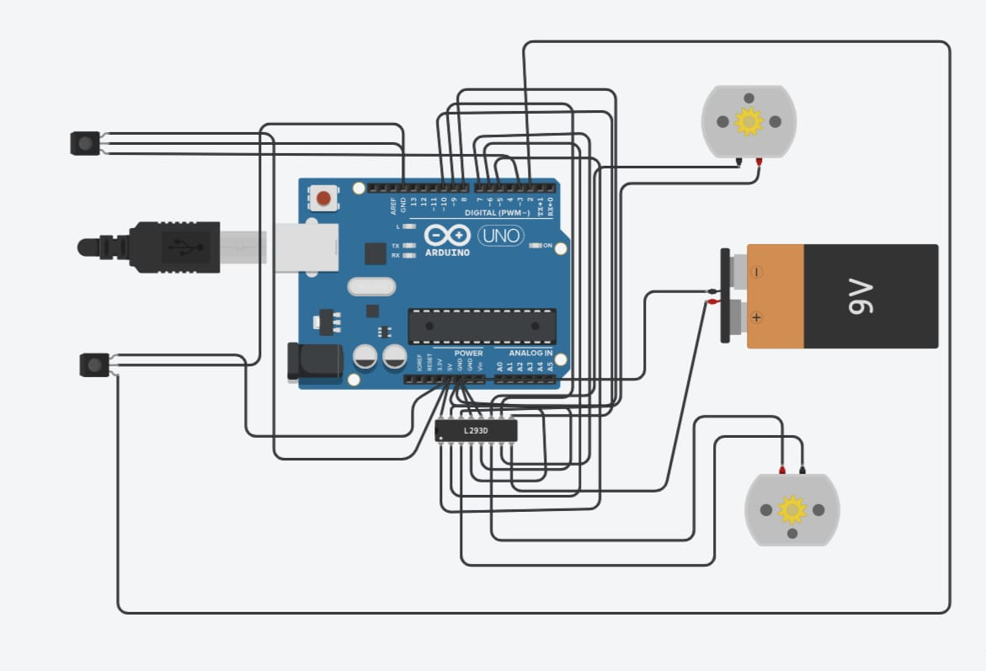

Fig. 8-PCB Layout
Fig. 5
Fig. 6
Appendix C
Project Photos

Fig. 3
Fig. 7

